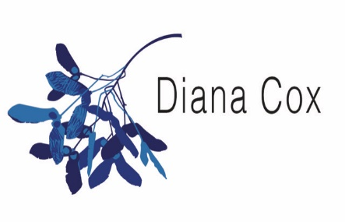

Terms & Conditions
These terms and conditions apply to Services provided by Diana Cox of Healing Hearts and Minds UK, Reiki Ramsgate and Reiki South London which for the purpose of these terms and conditions will be referred to as “we” or “us” or “our”. You the purchaser of the service for the purpose of these terms and conditions will be referred to as “the client” or “you”. These terms and conditions apply to the sale of any service that is purchased from us. By purchasing a service from us either online or in person you agree to the terms of this agreement.

The Services
A description of the Services you have agreed for us to provide is confirmed either on one of our websites or detailed in writing. We will provide the Services with reasonable care and skill in accordance with the description that has been advised.

Fees
The Fees for the Services shall be as set out on the description of the website or sent to you via invoice if purchasing offline, or as told to you at the time you placed an order via telephone or email.

Liability
No part of the provision of the Services is intended to be, nor should it be taken to be, a replacement for conventional medical treatment. We do not treat, prescribe for, or diagnose any condition nor guarantee results.

Cancellation Policy:

Client sessions
A booking is confirmed once we and the client have both agreed a date, time, duration and location for a treatment
- If a cancellation is made within 24 hours of the treatment, the client will be expected to pay a cancellation fee of £25 for each hour cancelled
- This cancellation fee may be waived at our discretion.
- The cancellation fee must be paid within 7 days of the cancellation
- We have the right to cancel a treatment without notice if the client is intoxicated, inebriated or exhibits unacceptable behaviour
Courses and workshops
Your place on a course or workshop will be confirmed once we have agreed a date, time and place with you and we have received the deposit payable.
- Course and workshop deposits are non-refundable.
- Reiki 1 and Reiki 2 course deposits may be transferred to a future course at our discretion if notice given no less than two weeks before the course commencement
- Reiki 1 and Reiki 2 course payment balances are due in full on the date of the course.
- For all other courses and workshops, please see below
If you cancel a course or workshop booking, except as detailed above, a cancellation fee will be charged, as follows:
- Up to 3 weeks prior to the workshop – 25% of the full course fee
- Up to 1 week prior to the workshop – 50% of the full course fee

Payment
- We accept payment in cash, by cheque, by credit/debit card (in person) or bank transfer.

Please contact via email reikiramsgate@gmail.com for any queries.

Our websites: reikiramsgate.co.uk reikisouthlondon.co.uk healingheartsandminds.co.uk

